University of Southern Mississippi

Region I Science & Engineering Fair

Registration Guide (2019)

This guide will serve as instructions to assist with fair registration using the new online platform. Please contact us at 601.266.4048 for any questions.

1. Use the following link: <https://sciencefair1.usm.edu/fairs> to go to the registration webpage.
2. Click on the appropriate button to register for the fair. The button is below the table with the dates.

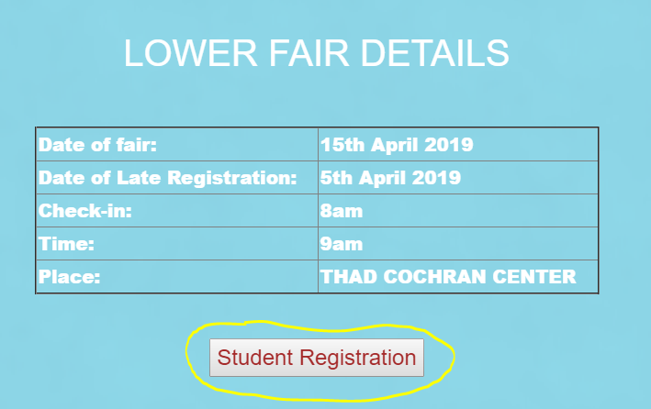

1. Please review all instructions to ensure that you can fill out the online form as accurately as possible.
2. Click on “Fill the Form” at the bottom of the page to being filling out the student’s registration.
3. The email given for the Adult Sponsor/Teacher field will be the one to receive the confirmation email. I suggest that you use the email of the person filling the form and forward the confirmation to all parties upon completion.
4. From this point, use the “Previous” and “Next” instead of the pressing back on the browser.

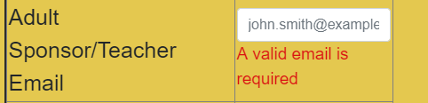

1. Ensure that you check “None” if you are not purchasing a shirt. It will not let you move on without responding.
2. Make sure you select your method of payment. It is for bookkeeping purposes.

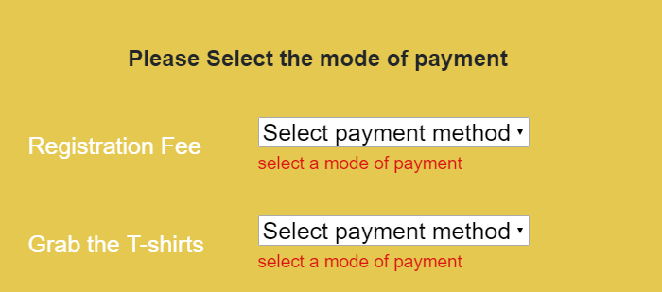

1. Project summaries/abstracts do not have to be entered but it is highly suggested that it is included with the forms in the research journal.
2. Upon completion, you will see a confirmation page before registering. Please review all submissions for accuracy. If incorrect, use the “Previous” to go back and make any corrections.
3. You will see a prompt if you successfully register.

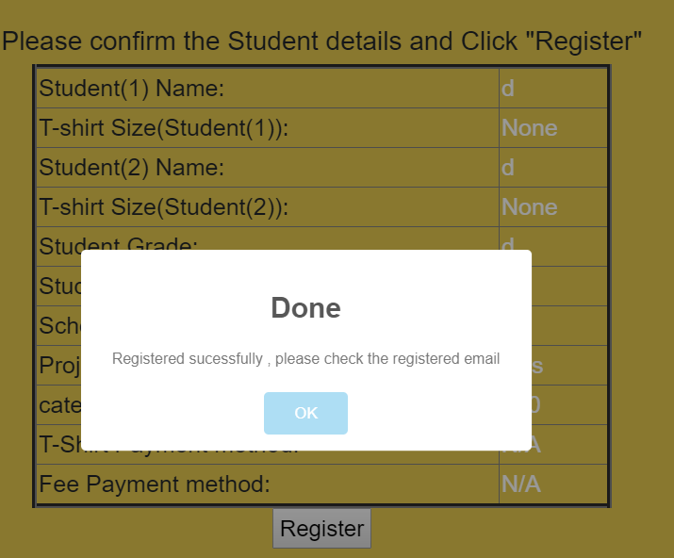

1. The last page will guide you through the payment process.

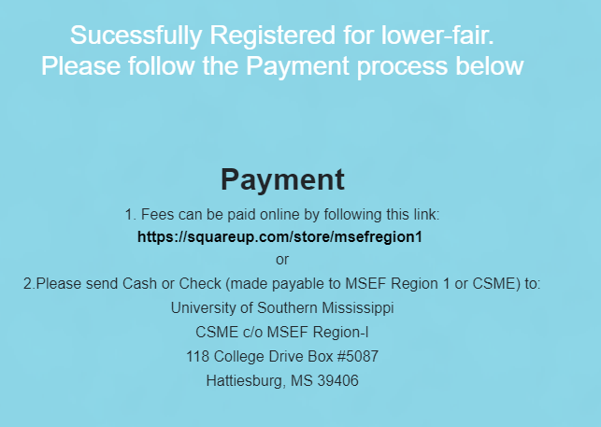

Contact us if you have any questions.